Multiple-choice section

|  |  |  |  |  |  |  |  |  |  |
| --- | --- | --- | --- | --- | --- | --- | --- | --- | --- |
| Question | 1 | 2 | 3 | 4 | 5 | 6 | 7 | 8 | 9 |
| Answer | D | C | A | C | C | D | B | B | A |

Question 1 [4.6] [10A]

D

5x2 = 3x – 7

5x2 – 3x + 7 = 0

ax2 + bx + c = 0

a = 5, b = -3, c = 7

Question 2 [4.5] [10A]

C

6x2 – x – 15

= 6x2 – 10x + 9x – 15

= 2x(3x − 5) + 3(3x − 5)

= (2x + 3)(3x – 5)

Question 3 [4.6] [10A]

A

x = 7 and x = -0.5

x – 7 = 0 and x + 0.5 = 0

(x – 7) and (2x + 1) are factors

(x – 7)(2x + 1) = 0

Question 4 [4.6] [10A]

C

(2x – 3)(4x + 5) = 0

As each factor can be equated to 0, the null factor law is the quickest way to solve this equation.

Question 5 [4.1]

C

x2 – 14x – 72 = 0

(x – 18)(x + 4) =0

x = 18, x = -4

Question 6 [4.3]

D



Question 7 [4.3]

B

By completing the square:



Question 8 [4.2]

B

x2 + 8x – 3

= x2 + 8x +  –  – 3

= x2 + 8x + 16 – 16 – 3

= (x + 4)2 – 19

= (x + 4 + )(x + 4 – )

Question 9 [4.4]

A

By completing the square:



Turning point is (6, -77).

Multiple-choice total marks: 9

Short answer section

Question 10 3 marks [4.1]



Question 11 5 marks [4.6] [10A]

(a) 4x2 – 28x + 49  
= (2x)2 – 2 × 2x × 7 + 72  
Let a = 2x, b = 7  
4x2 – 28x + 49 = 0  
(2x – 7)2 = 0  
2x – 7 = 0  
x = 

(b)   
  
x can only be 9 as x = -2 would give a negative length for the square, which is not possible.

Question 12 5 marks [4.2, 4.3, 4.4]

(a) y = x2 + 3x + 1   
 = x2 + 3x + ** – **+ 1  
= 

(b) 

(c) x-intercepts where y = 0:  
(x + )2 – ** = 0   
(x + – ) (x +  + ) = 0  
(x +  – ) (x +  + ) = 0  
x = - ± 

x-intercepts: (- + , 0) and (- − , 0)

Question 13 3 marks [4.6] [10A]

7 × 8 = 56

Find factors of 56 with a sum of -18.

Use -14 and -4

7y4 – 14y2 – 4y2 + 8

= 7y2(y2 – 2) – 4(y2 – 2)

= (7y2 – 4)(y2 – 2)

y =  or y = ±2

Question 14 3 marks [4.2]

3x2 – 12x – 6

= 3(x2 – 4x – 2)

= 3(x2 – 4x +  –  – 2)

= 3(x2 – 4x + 4 – 4 – 2)

= 3[(x – 2)2 – 6]

= 3(x – 2 + )(x – 2 – )

Question 15 2 marks [4.6] [10A]

(a) 2x2 – 7x – 8 = 0   
x =   
=   
As ** can be evaluated, there are solutions.

(b) 5x2 – 3x + 6 = 0  
x = **  
 =   
As ** cannot be evaluated, there are no solutions.

Question 16 4 marks [4.4]

Students’ answers will vary. The equations must have a turning point at (4, -6).

(a) in the form y = ax2 + bx + c (b) in the form y = a(x – r)(x – s)

Question 17 4 marks [4.6] [10A]

Area = (2x + 1)(4x – 1)

8x2 + 2x −1 = 35

8x2 + 2x − 36 = 0

4x2 + x − 18 = 0

(4x + 9)(x − 2) = 0

Reject x = -2.25 as this will give negative dimensions.

x = 2

Length = 4x – 1 = 7 m

Width = 2x + 1 = 5 m

Question 18 5 marks [4.4]

(a) y = (ax + b)2 + c  
= a2(x + **)2 + c  
= a2(x + 3)2 + 7  
c = 7

(b) The x-coordinate of turning point is -3:  
**

(c) If a = 0, the equation would be a straight line not a parabola. ** does not exist for a = 0.

Question 19 4 marks [4.1]

(a)   


(b)   
  
The value t = -10 is not possible because the variable t (time) is a positive quantity.

(c) After 4 seconds the object is 200 m from its original position.

Question 20 6 marks [4.4]

(a)

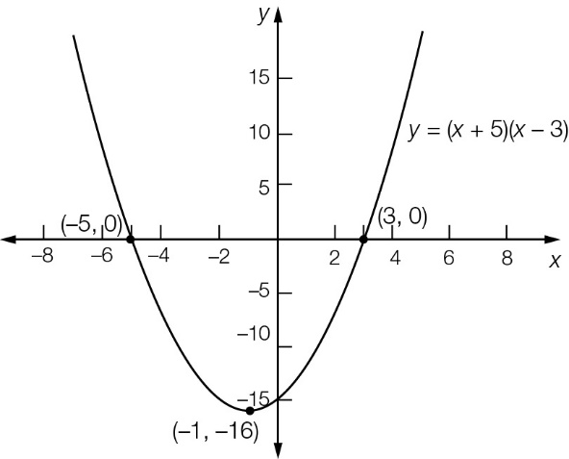

(b) This is true when p or q, or both, are zero. Either or both x- and y-intercepts will include the point (0, 0), so the graph must pass through it.

Question 21 4 marks [4.4]

(a) y = x2 + 2(a – 3)x + a2  
= x2 + 2(a – 3)x + (a – 3)2 + a2 – (a – 3)2  
= (x + (a – 3))2 + a2 – (a2 – 6a + 9)  
= (x – (3 – a))2 + (6a – 9)

(b) For (x – (3 – a))2 + (6a – 9):  
the x-coordinate of the turning point is (3 – a)  
the y-coordinate of the turning point is (6a – 9)  
3 – a = 8  
a = -5  
6a – 9 = 6 × -5 – 9  
= -39  
y-coordinate of turning point is -39.

Question 22 2 marks [4.2, 4.4]

Complete the square and write the equation in turning point form.



The x-coordinate of the turning point:  
x + a = 0  
x = -a

The y-coordinate of the turning point is b.

The turning point is (-a, b).

Short answer total marks: 50

Extended answer section

Question 23 5 marks [4.4]

(a) For h = 0:  
h = -3d2 + 240d  
0 = -3d(d – 80)  
d = 0 or d = 80.  
The distance to the target is 80 m.

(b) The maximum height is reached at the turning point, in the middle of the d-intercepts.  
For d = 40:  
h = -3 × 402 + 240 × 40  
= -4800 + 9600  
= 4800 metres

(c)

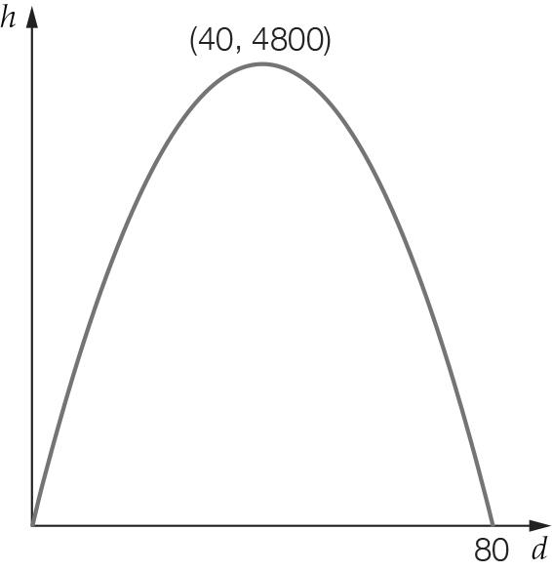

Question 24 5 marks [4.1]

(a) Area = 

(b)



(c) (i)



(ii)  but x must be ≥ 1.5R  
Therefore the shaded area can never be zero.   
A circle cut from a square will always leave waste.

Question 25 9 marks [4.1, 4.3, 4.4]

(a) y = 10x – x2

|  |  |  |  |  |  |  |  |  |  |  |  |
| --- | --- | --- | --- | --- | --- | --- | --- | --- | --- | --- | --- |
| x | 0 | 1 | 2 | 3 | 4 | 5 | 6 | 7 | 8 | 9 | 10 |
| y | 0 | 9 | 16 | 21 | 24 | 25 | 24 | 21 | 16 | 9 | 0 |

(b)

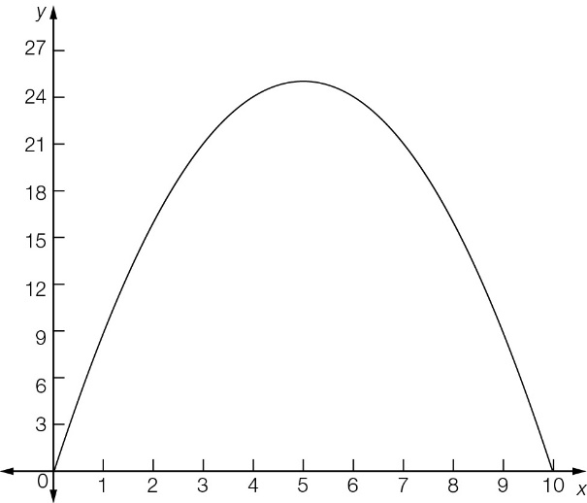

(c) (5, 25)

(d) y-intercept (0, 0); x-intercepts (0, 0), (10, 0)

(e) 6 = 10x – x2  
x2 – 10x + 25 – 25 + 6 = 0  
(x – 5)2 – 19 = 0  
x = 5 ±   
x = 9.36, 0.64

(f) The projectile is 6 m above the ground twice: on the way up and then on the way down.

(g) The projectile reaches a maximum height of 25 m. It does not reach the 30 m, so there are no solutions.

Question 26 4 marks [4.2, 4.3, 4.4]

(a) h = 0.002x(100 – x)  
 = 0.002(100x – x2)  
 = -0.002(x2 – 100x + 2500 – 2500)  
 = -0.002((x – 50)2 – 2500))  
 = -0.002(x – 50)2 + 5  
Highest level reached is 5 m

(b) 0.002(100x – x2) = 0  
100x – x2 = 0  
x(100 – x) = 0  
x = 0, 100  
It will land 100 m from where it was hit.

(c) h = 0.002(100x – x2)  
= 0.002(100 × 30 – 302)  
= 0.002(2100)  
= 4.2 m  
Yes, it will clear the tree by 20 cm.

Extended answer total marks: 23

TOTAL test marks: 82